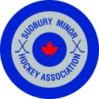
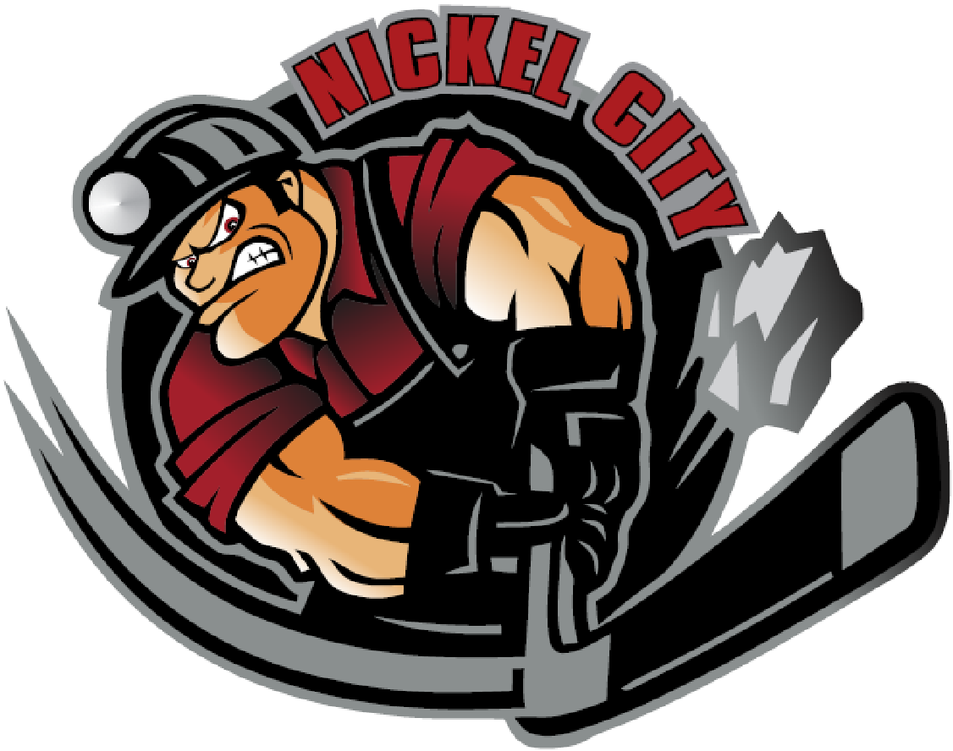

SMHA and NCHA are collaborating on AAA for the 2022-2023 Season!!

Just to keep everyone in the loop, SMHA and NCHA have agreed to hosting all tryouts in the Fall. Continue to visit our websites and our Facebook pages for more detailed information surrounding tryout dates for each age group and levels. As everyone knows, the OHF has mandated Fall tryouts for U7 through to U13 age groups. We feel that delaying the U14 through to U18 tryouts will provide us with more time to properly plan our joint tryouts. As well, we believe this will give interested individuals ample opportunity to consider applying for our combined clubs where applicable.

NCHA and SMHA board of directors have put together a AAA Team structure for the upcoming 2022/2023 season. We have agreed to collaborate @ the AAA level and will be seeking coaches for the following clubs. NCHA will be hosting the U12AAA, U13AAA and U14AAA teams, while SMHA will be icing the U15AAA, U16AAA and U18AAA clubs for the upcoming season.
Should you be interested in applying for any of these teams, please visit the NCHA or SMHA website for the application package. Please send your completed application to SMHA.NCHAhockey@gmail.com .

Best Regards

Gaston Lescault & Angela Vendette
President President
NCHA SMHA

