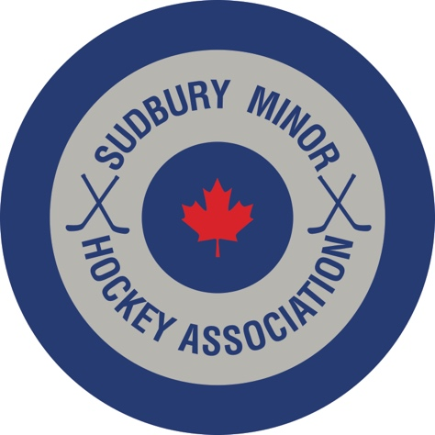

AAA Coaching Announcement for 2021-2022

The Sudbury Minor Hockey Association Board of Directors is pleased to announce the following coaches for AAA:

U18 AAA: Head Coach – Brian Dickinson

U16 AAA: Head Coach – Jordan Cheechoo

U15 AAA: Head Coach – Pending

U14 AAA: Head Coach – Dale Lafrance

U13 AAA: Head Coach – Andrew Dale

U12 AAA: Head Coach – Joey Dupuis

AA and A Coaches to be announced in the near future.

